**DESIGN AND ANALYSIS OF CIRCULAR PATCH ANTENNA SYSTEMS**

Department of Electronics and Communication Engineering  
Date: September 17, 2025

**EXECUTIVE SUMMARY**

This report presents a comprehensive analysis of **circular patch antenna** systems that provide efficient radiation solutions for wireless communication applications. Circular patch antennas achieve **moderate directional gain** (3-8 dBi) with broadside radiation characteristics through their circular geometry on grounded substrates. The analysis demonstrates that well-designed circular patch systems can achieve good impedance matching, stable radiation patterns, and efficient performance for applications ranging from WLAN to 5G communications.

**1. INTRODUCTION**

**1.1 Background**

The **circular patch antenna** consists of a circular metallic patch printed on a grounded dielectric substrate. This configuration creates a resonant cavity that radiates electromagnetic energy efficiently at microwave frequencies.

**1.2 Operating Principles**

Circular patch antennas operate through **cavity resonance** where the patch and ground plane form a resonant cavity. The circular geometry provides **rotationally symmetric** current distributions that generate broadside radiation patterns with linear or circular polarization capabilities.

**1.3 Key Advantages**

Circular patches offer **symmetrical radiation patterns, dual polarization capability, compact size, and simple fabrication** using standard PCB processes. The circular geometry eliminates corner effects present in rectangular patches.

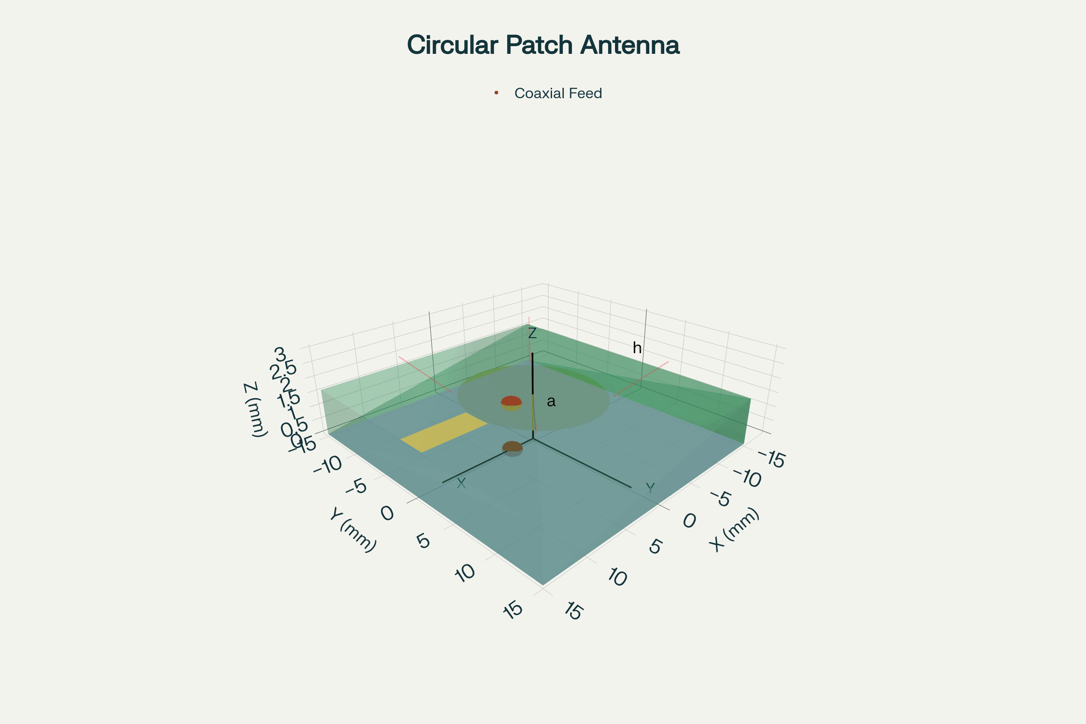

Figure 1 – Circular microstrip patch antenna structure showing patch radius 'a', substrate thickness 'h', and feeding arrangements.

**2. THEORETICAL FOUNDATIONS**

**2.1 Resonant Frequency Calculation**

The resonant frequency of a circular patch is determined by the **patch radius 'a'** and substrate parameters. The fundamental TM₁₁ mode resonant frequency is calculated using:

**f = c × 1.841 / (2π × aₑ × √εᵣₑff)**

where aₑ is the effective radius accounting for fringing fields.

**2.2 Effective Radius**

The **effective radius** includes fringing field effects and is given by:  
**aₑ = a[1 + (2h/πaεᵣ)[ln(πa/2h) + 1.7726]]^0.5**

This accounts for the extension of the electric field beyond the physical patch boundaries.

**2.3 Current Distribution**

The **surface current distribution** for the TM₁₁ mode creates two current maxima separated by 180°, resulting in linearly polarized radiation. Higher-order modes can be excited for circular polarization.

**3. RADIATION CHARACTERISTICS**

**3.1 Pattern Properties**

Circular patch antennas produce **broadside radiation patterns** with maximum gain perpendicular to the patch surface. The patterns exhibit good symmetry due to the circular geometry.

**3.2 E-plane and H-plane Patterns**

The **E-plane pattern** (containing the electric field vector) and **H-plane pattern** (containing the magnetic field vector) show similar characteristics for circular patches, with beamwidths typically ranging from 60° to 90°.

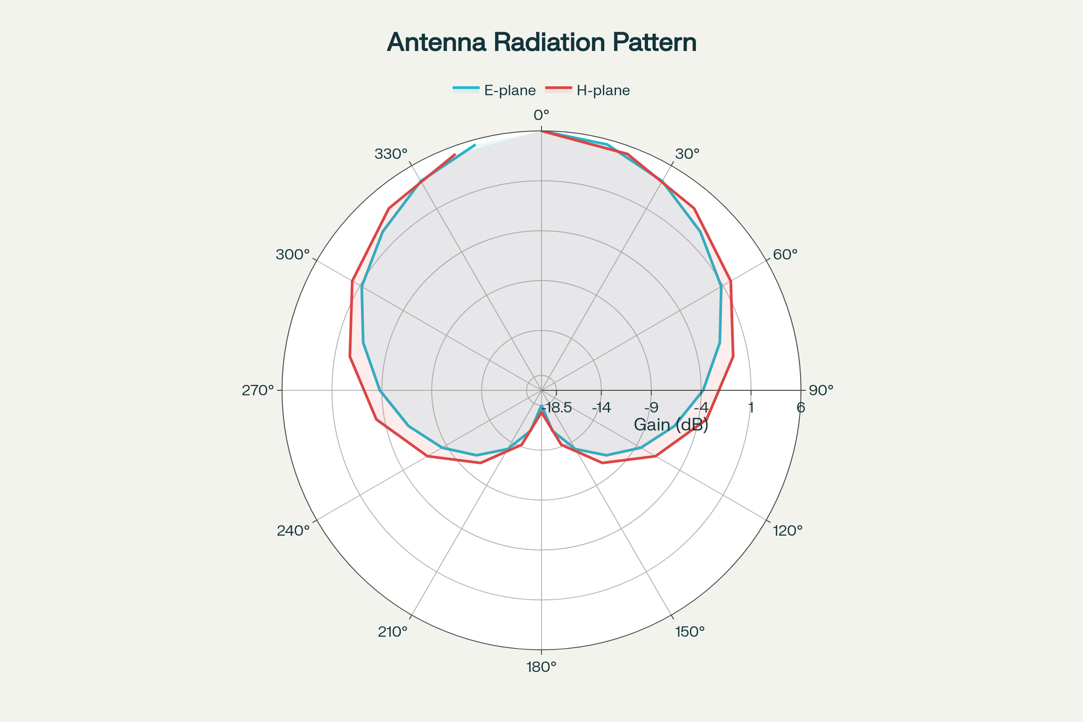

Figure 2 – Circular patch antenna radiation patterns showing E-plane and H-plane characteristics with broadside radiation.

**3.3 Gain Performance**

**Antenna gain** typically ranges from 3-8 dBi depending on substrate thickness and dielectric constant. Thicker substrates with lower dielectric constants generally provide higher gain.

**4. FEEDING TECHNIQUES**

**4.1 Contact Methods**

**Coaxial probe feeding** and **microstrip line feeding** provide direct electrical contact to the patch. These methods offer simple implementation but can introduce spurious radiation from the feed network.

**4.2 Non-Contact Methods**

**Aperture coupling** and **proximity coupling** eliminate direct electrical contact, reducing spurious radiation and cross-polarization. These methods provide better bandwidth and pattern purity.

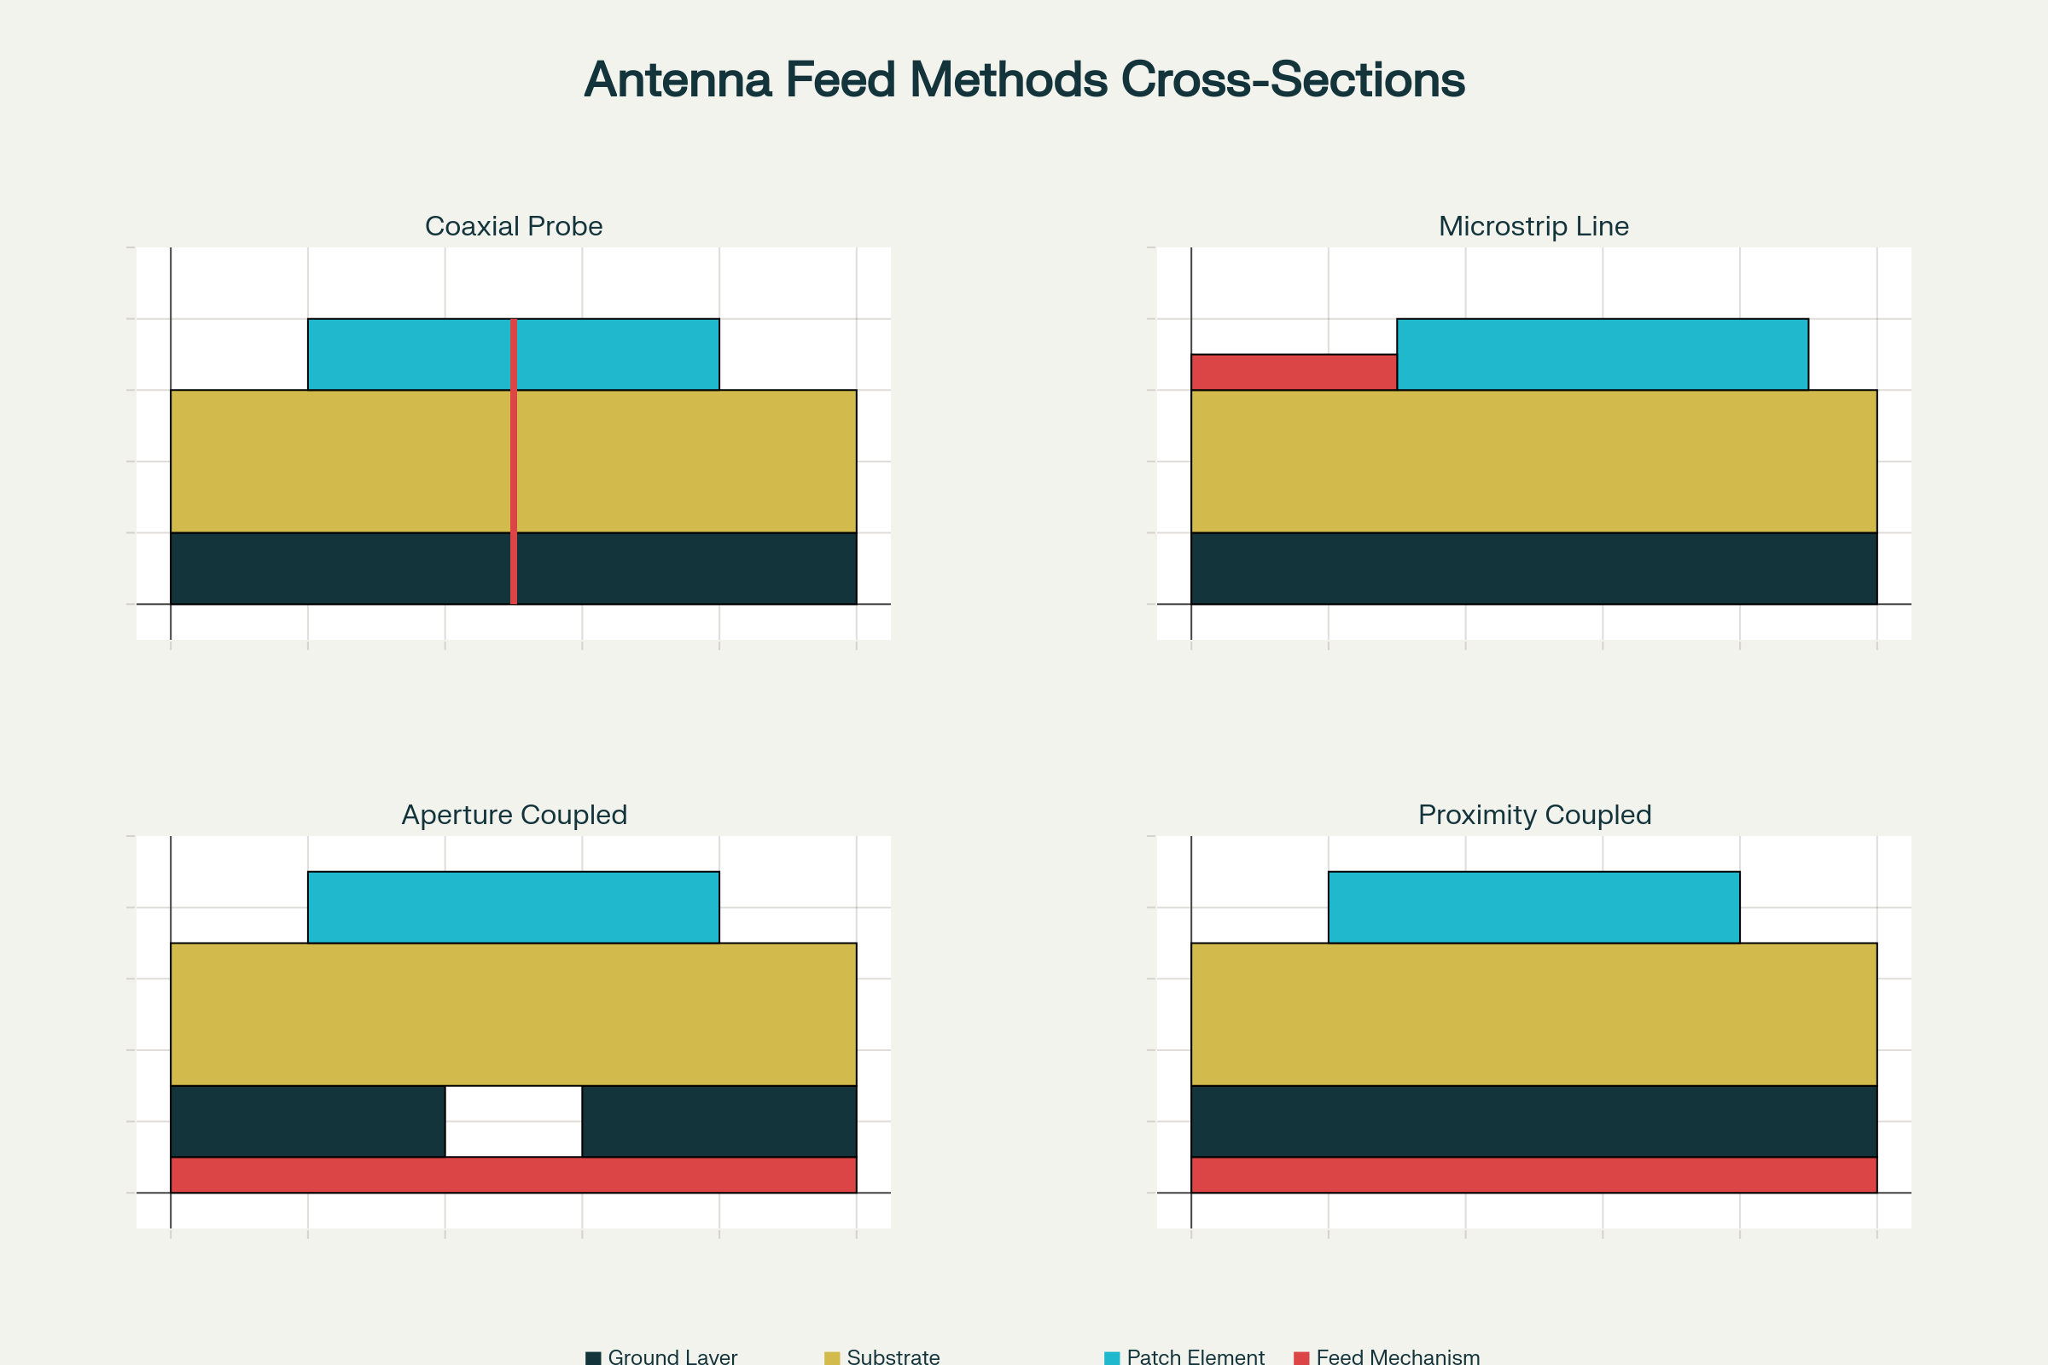

Figure 3 – Four feeding methods for circular patch antennas: coaxial probe, microstrip line, aperture coupled, and proximity coupled.

**4.3 Feed Position Optimization**

The **feed point location** significantly affects input impedance. For coaxial feeds, positioning closer to the patch center increases impedance, while edge feeding provides lower impedance values.

**5. PERFORMANCE CHARACTERISTICS**

**5.1 Frequency Response**

Circular patch antennas exhibit **narrow bandwidth** characteristics typical of resonant structures. The bandwidth is typically 2-5% of the center frequency for thin substrates.

**5.2 Return Loss and VSWR**

**Return loss** better than -10 dB and **VSWR less than 2:1** are typically achieved across the operating bandwidth. The resonant frequency shows minimum return loss values.

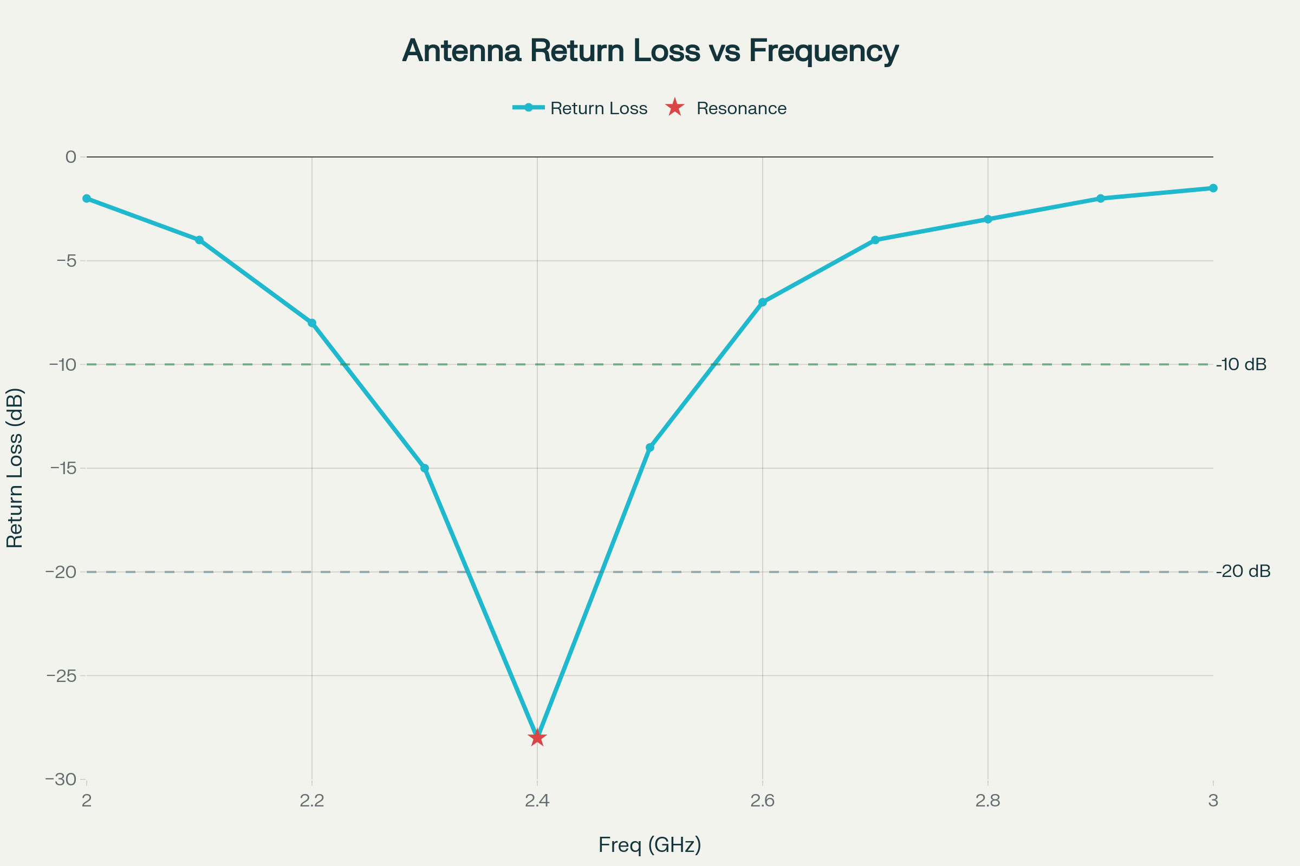

Figure 4 – Circular patch antenna frequency response showing return loss, VSWR, gain, and efficiency across 2.0-3.0 GHz band.

**5.3 Efficiency Characteristics**

**Radiation efficiency** ranges from 50% to 95% depending on substrate losses and conductor quality. Higher efficiency is achieved with low-loss substrates and good conductor materials.

**6. DESIGN METHODOLOGY**

**6.1 Substrate Selection**

**Substrate thickness** should be between 0.03λ to 0.05λ for optimal performance. Common materials include FR-4 (εᵣ = 4.4), Rogers materials, and ceramic substrates for high-frequency applications.

**6.2 Dimensional Calculations**

For a **2.4 GHz design** on FR-4 substrate (h = 1.4 mm), typical dimensions include:

* **Patch radius**: 7.6-8.0 mm
* **Substrate size**: 30×30 mm minimum
* **Ground plane**: Full substrate coverage

**6.3 Impedance Matching**

**50Ω impedance matching** is achieved through proper feed positioning and, if necessary, inset feeding or impedance transformers. Microstrip line feeds require quarter-wave transformers for optimal matching.

**7. APPLICATIONS**

**7.1 WLAN Communications**

**2.4 GHz and 5 GHz** WLAN applications extensively use circular patches for access points and client devices. The omnidirectional characteristics suit indoor coverage requirements.

**7.2 5G and Millimeter-Wave**

**28 GHz 5G applications** employ compact circular patches with dimensions around 1.5 mm radius. These antennas enable phased array implementations for beamforming.

**7.3 Satellite Communications**

**C-band and Ku-band** satellite applications use circular patches for mobile terminals and fixed installations. Circular polarization capability is particularly valuable for satellite links.

**7.4 RFID Systems**

**UHF RFID** readers and tags utilize circular patches for their symmetric patterns and dual-polarization capabilities. The 902-928 MHz ISM band is commonly targeted.

**8. DESIGN VARIATIONS**

**8.1 Slotted Configurations**

**Circular slots** within the patch enhance bandwidth and enable dual-band operation. Square slots in the ground plane can improve impedance matching and pattern characteristics.

**8.2 Stacked Patches**

**Multi-layer stacked** circular patches provide enhanced bandwidth and gain. The parasitic patches are electromagnetically coupled to the driven element.

**8.3 Array Configurations**

**Circular patch arrays** achieve higher gain and beam steering capabilities. Proper element spacing and feeding networks enable pattern control and null steering.

**9. MEASUREMENT TECHNIQUES**

**9.1 S-Parameter Analysis**

**Vector network analyzers** characterize impedance matching and return loss across frequency. Calibrated measurements ensure accurate impedance data.

**9.2 Radiation Pattern Testing**

**Anechoic chamber measurements** provide accurate pattern data free from reflections. Near-field scanning can determine far-field patterns for electrically large structures.

**9.3 Gain and Efficiency**

**Comparative measurements** using standard gain antennas determine absolute gain values. Efficiency measurements require careful loss accounting for complete characterization.

**10. ADVANTAGES AND LIMITATIONS**

**10.1 Advantages**

* **Symmetric radiation patterns** due to circular geometry
* **Dual polarization capability** with proper excitation
* **Simple fabrication** using standard PCB processes
* **Low profile** suitable for conformal installations
* **Good impedance matching** achievable across bandwidth

**10.2 Limitations**

* **Narrow bandwidth** compared to other antenna types
* **Lower gain** than horn or reflector antennas
* **Surface wave losses** in thick substrates
* **Temperature sensitivity** affecting resonant frequency
* **Ground plane requirements** for proper operation

**11. COMPARATIVE ANALYSIS**

|  |  |  |  |  |
| --- | --- | --- | --- | --- |
| Parameter | Circular Patch | Rectangular Patch | Dipole | Horn |
| **Bandwidth** | 2-5% | 2-8% | 10-15% | 20-100% |
| **Gain (dBi)** | 3-8 | 4-9 | 2-3 | 10-25 |
| **Profile** | Very Low | Very Low | Medium | High |
| **Polarization** | Linear/Circular | Linear | Linear | Linear/Circular |
| **Complexity** | Low | Low | Very Low | Medium |

*Table 1: Performance comparison of antenna types*

**12. FUTURE DEVELOPMENTS**

**12.1 Metamaterial Integration**

**Metamaterial substrates** enable size reduction and bandwidth enhancement for circular patches. These engineered materials provide new degrees of design freedom.

**12.2 Reconfigurable Designs**

**Electronically reconfigurable** circular patches use PIN diodes or varactors for frequency tuning and pattern control. These capabilities support software-defined radio applications.

**12.3 3D Printing Technology**

**Additive manufacturing** enables complex geometries and integrated feeding structures previously impossible with conventional fabrication. Multi-material printing allows dielectric-conductor integration.

**13. CONCLUSION**

Circular patch antennas represent **fundamental building blocks** for modern wireless communication systems, offering symmetric radiation characteristics and simple fabrication in a compact form factor. The four images included in this report illustrate key concepts: antenna structure and feeding methods, radiation pattern characteristics, comparative feeding techniques, and frequency response behavior.

The **circular geometry** provides advantages in pattern symmetry and dual-polarization capability while maintaining the low-profile benefits of microstrip technology. Success requires careful attention to substrate selection, dimensional scaling, and feeding technique optimization to achieve desired performance specifications.

Future developments in **metamaterials, reconfigurable designs, and advanced manufacturing** will continue expanding circular patch antenna capabilities while maintaining the core advantages of simplicity, compactness, and reliable performance across diverse wireless applications.

**REFERENCES**

1. <https://aircconline.com/ijans/V11N3/11321ijans01.pdf>

1. <https://jnep.sumdu.edu.ua/download/numbers/2023/3/articles/jnep_15_3_03007.pdf>

1. <https://wseas.com/journals/communications/2015/a365704-693.pdf>

1. [https://ijaem.net/issue_dcp/Design and Simulation of Circular Patch Antenna for Different Substrates and Feeding Techniques.pdf](https://ijaem.net/issue_dcp/Design%20and%20Simulation%20of%20Circular%20Patch%20Antenna%20for%20Different%20Substrates%20and%20Feeding%20Techniques.pdf)

1. <https://www.irjms.com/journal/a-novel-circular-ring-microstrip-patch-antenna-for-bandwidth-enhancement-and-harmonic-suppression/>

1. <https://www.dolphmicrowave.com/default/what-are-the-4-feeding-methods-for-microstrip-patch-antenna/>

1. [http://www.ijlemr.com/papers/volume7-issue10/Design and Construction of a Circular Microstrip Patch Antenna for Bluetooth Band Applications.pdf](http://www.ijlemr.com/papers/volume7-issue10/Design%20and%20Construction%20of%20a%20Circular%20Microstrip%20Patch%20Antenna%20for%20Bluetooth%20Band%20Applications.pdf)

1. <http://article.sapub.org/10.5923.j.ijea.20150503.01.html>

1. <https://www.ijraset.com/research-paper/rectangular-and-circular-microstrip-patch-antenna->

1. <https://www.ijert.org/research/circular-microstrip-patch-antenna-using-coaxial-feed-for-s-band-application-IJERTV3IS051677.pdf>

1. [https://courses.egr.uh.edu/ECE/ECE5318/Introduction to Microstrip Antennas.pdf](https://courses.egr.uh.edu/ECE/ECE5318/Introduction%20to%20Microstrip%20Antennas.pdf)

1. <https://www.vinoth.org/rf-calculators/circular-patch-antenna-calculator>

1. <https://www.youtube.com/watch?v=Pyc9BdT25fM>

1. <https://ijcrt.org/papers/IJCRT2105532.pdf>

1. <https://etasr.com/index.php/ETASR/article/download/7961/3933/32118>

1. <https://www.geeksforgeeks.org/electronics-engineering/microstrip-patch-antenna/>

1. <https://ijcaonline.org/archives/volume178/number27/mohammed-2019-ijca-919010.pdf>

1. <https://www.sciencedirect.com/science/article/pii/S2590123024005747>

1. <https://www.ieice.org/~isap/ISAP_Archives/2009/pdf/1374.pdf>